Capitalism: Part of American Exceptionalism?

The U.S. is founded on capitalism, which even this patriotic black vulture celebrates.
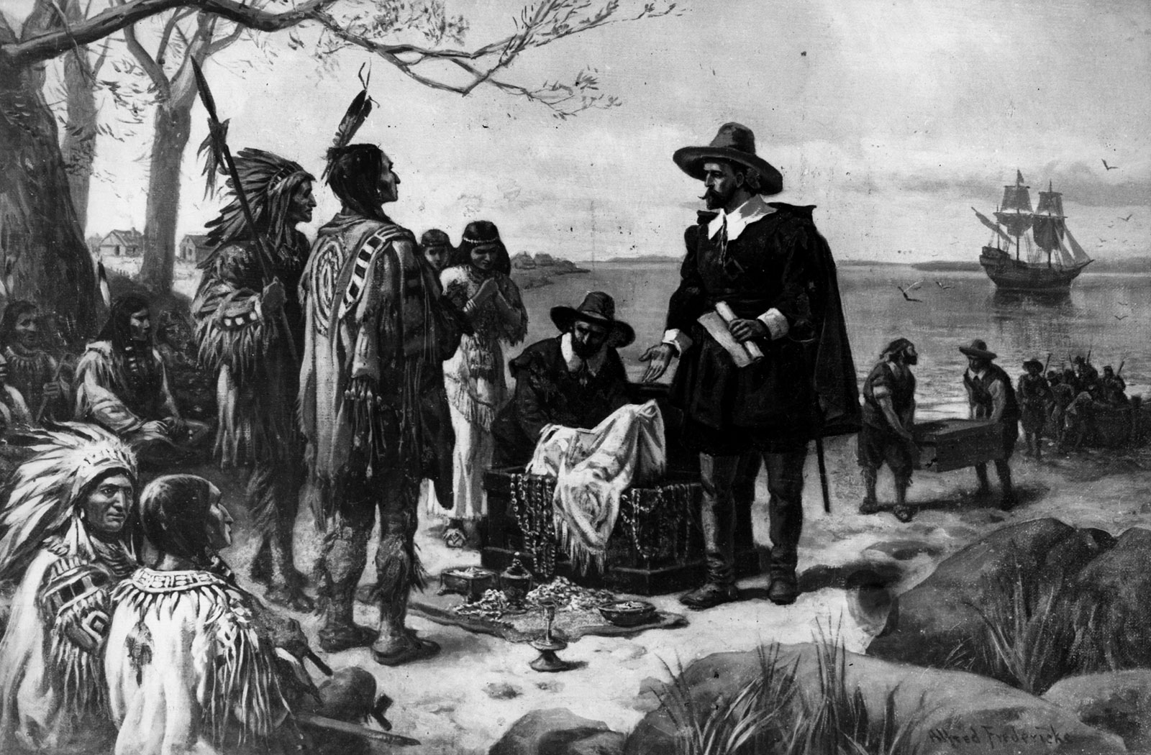
The Dutch buy Manhattan for $24.

We want Alexander Hamilton,
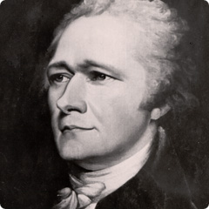
The first Treasury Secretary establishing the country on a firm financial foundation.
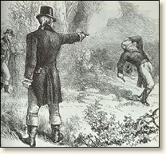We also get Aaron Burr, developer of the political machine (who killed Hamilton in a duel).

We want Abe Lincoln, 16th and perhaps greatest president
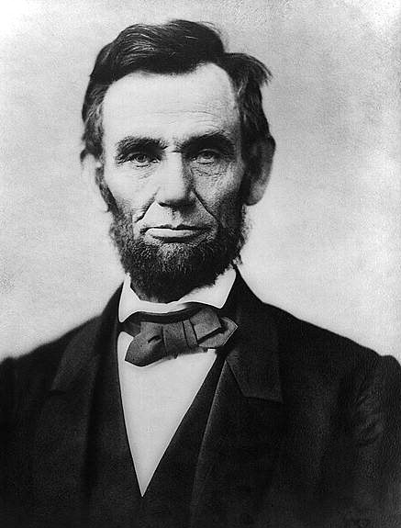

We also get Boss Tweed, Grand Sachem of Tammany Hall
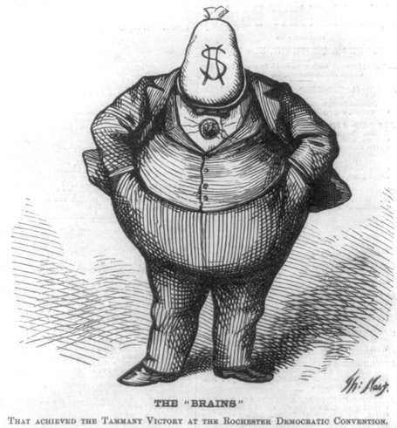

We want the transcontinental railroad, amazing engineering connecting the country from coast to coast.
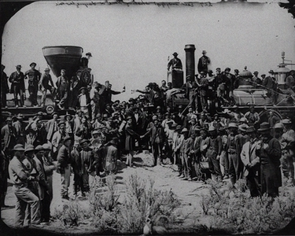

We also got the biggest 19th century business scandal with Credit Mobilier and Robber Barons Jay Gould and Jubilee Jim Fisk.
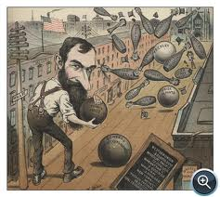

We want John D. Rockefeller, creator of the modern corporation
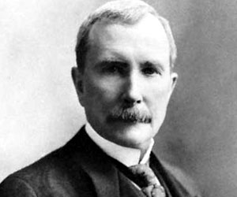
+ John. D. Rockefeller, creator of the American monopoly 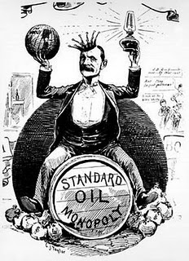

We want Charles Merrill, founder of Merrill Lynch
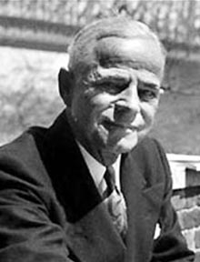
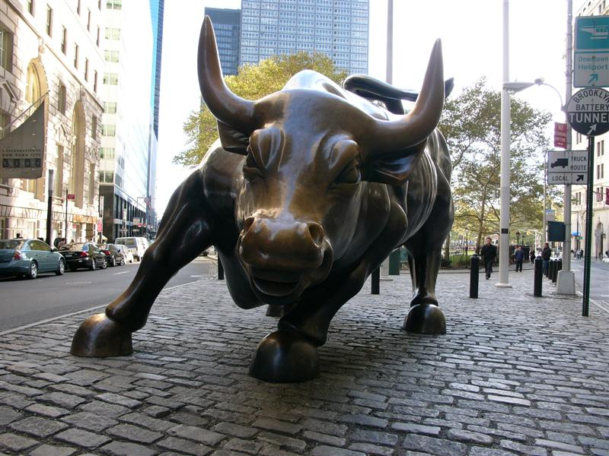

We also get Stan O’Neal, CEO of Merrill, driving it toward failure (and exiting with an extreme pay package). Famous line: “as long as the music’s playing, you got to keep dancing.”
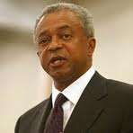
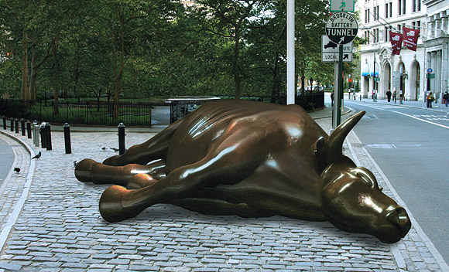

We want Warren Buffett, brilliant CEO of Berkshire Hathaway
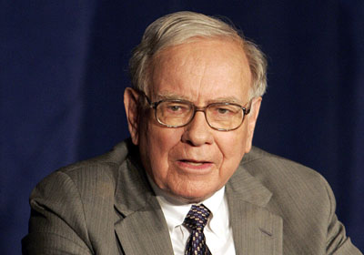
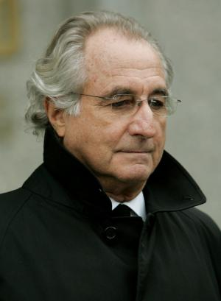
We also get Bernie Madoff, the biggest Ponzi schemer.
Why?
Money, $$ ££ ¥¥. Rule 1: follow the money.
Power; some leaders are drawn to power, other strictly to money, most probably like both.
Incentives drive actions; if the incentives are misdirected (think Enron), they will be met anyway.
Executives want millions; compensation contracts should be long-term and promote real corporate growth. Apparently, this is difficult to achieve. 

They may get the perp walk.
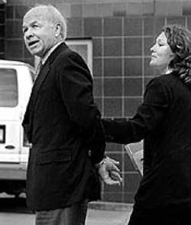
Ken Lay, Enron CEO, convicted of securites fraud and other charges.

Steve Jobs is a great American success story.


Richard Fuld also is a great story.
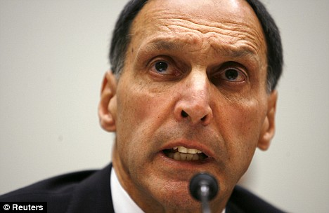
CEO of Lehman Brothers, biggest bankruptcy in American history.
Corruption seems fundamental to conniving capitalism.
Capitalism revolves around individual success, ultimately measured by money and power; the incentives to cheat are great and the system breeds willing participants.
Corruption and scandals have always been part of the American story.
The 21st century brought out the most sophisticated economic behavior and complex regulations, but matched by sophisticated corruption.

